**USING RAPTOR –DISPLAY PRIME NUMBERS BETWEEN 1 AND 100**

**R.NIVEDITHA**

**192110054**

**FLOWCHART**

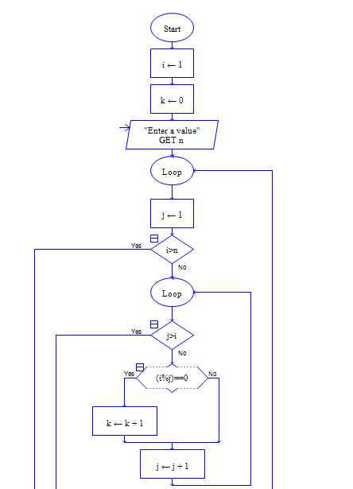

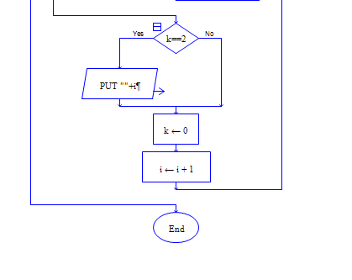

**INPUT**

100

**OUTPUT**

